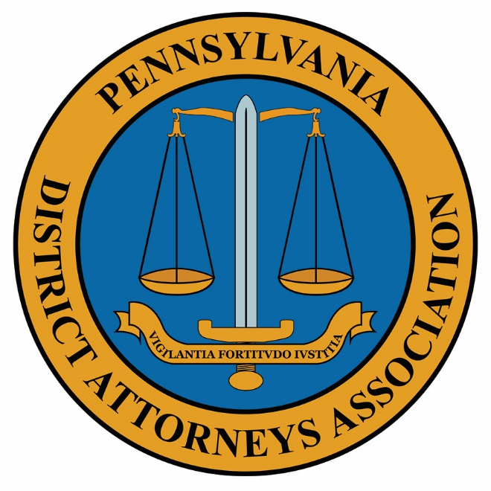

Testimony before Senate Aging & Youth and Banking & Insurance Committees on September 18, 2024, submitted by
Kelly Callihan, Executive Director

Good morning. Thank you for giving PDAA the opportunity to submit written testimony for the joint public hearing before the Senate Aging & Youth and Banking & Insurance Committees on the important topic of elder financial exploitation.
Seniors are especially vulnerable to becoming victims of crime due to their financial stability, caring nature, ease in trusting others and sometimes loneliness or desire for meaningful connections. Criminals use false pretenses to victimize them while taking advantage of their kindness and empathy.
It is important to keep seniors in Pennsylvania safe from crimes that target their assets and threaten their financial stability. Pennsylvania prosecutors are leaders in their respective counties when it comes to educating the elder population of these risks and doing their part to prevent them while continually improving measures to identify, report, investigate and prosecute those who scam this vulnerable population.
The Pennsylvania Department of Aging predicts by the year 2030, 27.5% of Pennsylvanians will be over age 60. Financial Exploitation Resources | Department of Aging | Commonwealth of Pennsylvania. Now is the critical time to increase awareness and implement preventive measures. This is an all-hands-on deck undertaking. In the past the legislature has recognized the vulnerable status of older adults by enhancing penalties when victims of fraud are 60 years or older. With the advancements in technology including common use of cell phones, social media, phishing scams and most recently the introduction of Artificial Intelligence, more must be done.
While it is great that seniors enjoy the benefits of using technology to connect with friends and family, it also subjects them to unwanted, manipulative scams designed to gain access to financial accounts or personal information. We often hear of scams targeting the financial resources of grandparents who are led to believe a grandchild is in danger if money is not provided or false requests for bank account or personal information. Emails may direct victims to fake links or provide deceitful instructions for transferring funds or credit card information. There are even times when seniors send money believing they’ve won a prize only to find out there is no payout.
Police are often called after the fact when there is little chance of recouping the loss. These investigations require technical, specialized knowledge. Law enforcement needs training and resources along with better working relationships and information sharing with financial institutions. Elder abuse task forces are vital and have enhanced collaboration at the local level between local, state and federal partners leading to more successful prosecutions. But more needs to be done.
The bottom line is many victims lose their life savings to scams. Criminals target and manipulate those who have accumulated wealth for their retirement years as they become more dependent on others and often experience health and mental declines.
Prosecutors are key partners in the mission to decrease the risk that seniors will be targeted by the criminal element through education, awareness, and prevention efforts. That is why prosecutors’ offices actively participate in anti-fraud and abuse programs that educate seniors and their extended family members or caregivers on how to be safe on the internet, in their homes, and while using their phones or email accounts. It is also why prosecutors work collectively with police and local service providers, including county Area Agencies on Aging, to identify elder physical, sexual, and financial abuse and hold offenders accountable.
PDAA hopes that our identification of these issues is helpful and welcomes further discussion going forward.

