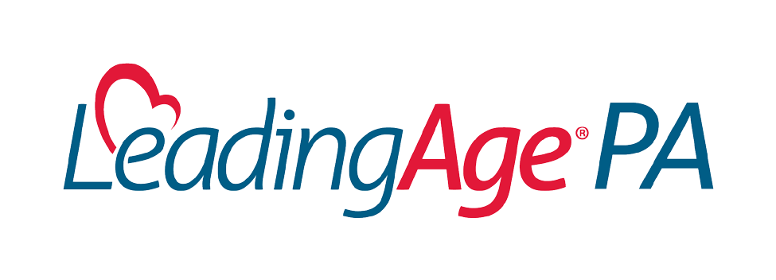

**TESTIMONY**

**Joint Hearing of the Pennsylvania Senate**

**Insurance and Banking & Aging and Youth**

**Committees on Financial Exploitation and Broader**

**OAPSA Reform**

**September 18, 2024**

**Submitted by:**

**Garry Pezzano, President & CEO**

**LeadingAge PA**

September 18, 2024

Chairman DiSanto, Chairman Street, Chairwoman Ward, Chairwoman Collett, and honorable members of the Senate Banking and Insurance and Aging and Youth committees, LeadingAge PA is grateful for the opportunity to offer testimony today before this joint committee about the continuum of aging services, House Bill 2064 (which seeks to establish greater financial protections for seniors), and, more broadly, the Older Adult Protective Services Act (OAPSA). The membership of LeadingAge PA is comprised of 414 providers of senior housing, health care, and community services across the Commonwealth. Our members include personal care homes, assisted living residences, LIFE providers, skilled nursing, affordable housing developments, and continuing care retirement communities. Our members provide adult day services, home health care, home care, hospice, and independent living options for older adults.

House Bill 2064 establishes reporting requirements for financial institutions to the Department of Aging and the Office of the Attorney General. LeadingAge PA understands the intent and purpose of the current version of House Bill 2064 in protecting seniors’ finances from scams and abuse. Protecting and caring for seniors are pillars for our mission-driven provider members.

With that said, LeadingAge PA has significant concerns with the Department of Aging’s proposal to make omnibus changes to the Older Adult Protective Services Act. Any reforms to OAPSA must balance the realities of our state’s current workforce shortages, providers’ ability to serve the growing older population’s needs, and effective protective services to older adults.

Safeguarding seniors’ well-being includes ensuring they have access to quality care and a direct care workforce to deliver that care.

In 2019, the Department of Aging and the Long-Term Care Council published *A Blueprint for Strengthening Pennsylvania’s Direct Care Workforce*. The report shed light on (at the time) the impending workforce and access to care crises and stated:

* “By 2026, the Commonwealth will need over 37,000 more direct care workers.”
* “By 2030, the population of older adults is expected to increase by 26%, with residents

85 and older increasing by over 80,000 individuals.”

Fast forward just five years later, when earlier this year, the Department of Aging recently released *Aging Our Way*, *PA*, setting in motion a ten-year master plan to meet the needs of the Commonwealth’s seniors. This plan clearly recognizes that Pennsylvania is confronted with a shortage of direct care workers needed to meet the future needs of our senior population, stating, “Inadequate supply of direct care workers multiplies the difficulties families face as they piece together supports and services for their loved ones.” Furthermore, in 2021 the Pennsylvania Department of Health passed regulatory reforms for nursing homes, including mandating that all facilities increase minimum staffing standards, which included:

* Increases from 2.7 per patient day (PPD) hours to 2.87 PPD and per shift ratios beginning July 1, 2023 (year 1).
* Year 2 increases of 3.2 PPD and further increased per shift ratios went into effect on

July 1st of this year.

The addition of these ratios is causing added strain when the workforce infrastructure is not strong enough to fill the increased demand. Placing additional barriers to growing the direct care workforce and exposing providers to liability is another undue burden on the aging services ecosystem that the Commonwealth simply cannot afford. The Department of Aging’s most recent proposal fails to balance these realities of providers and the department’s goal of protective services.

# Barriers to the Aging Services Workforce

All direct care workers (DCWs) are currently required to submit Pennsylvania State Police (PSP) checks, and if they have lived outside of the state within two years prior to being hired, they must also submit Federal background checks. These requirements are in addition to other prerequisites to work in senior care, including proof of any relevant license/certification, tuberculosis (TB) testing, and general onboarding.

* Based on the current proposal, it is unclear whether current employees are grandfathered into the act.
* The hiring environment in aging services is already intensive and often causes candidates to abandon their onboarding in favor of jobs that can begin earning a paycheck in a timelier manner.
* Requiring all applicants to submit these checks will inevitably extend the onboarding of critical DCWs.

The proposed language would also require providers to bear the cost of these additional background checks. While providers may elect to cover those costs, they should not be required to.

* $26.20 per Federal Bureau of Investigation (FBI) background check, plus $22.00 per criminal history record. (total of $48.20/employee check)

Imposing these added costs in addition to initial costs of onboarding and training on providers who, in the midst of a workforce crisis, are already underfunded for the care they provide further exemplifies the department’s lack of understanding regarding the impact major reforms to OAPSA would have on the aging services community.

The current proposal also does not include any accountability measures for the department to ensure adequate access to background check processing sites. Providers advocated for these parameters to be included to ensure that obtaining a background check is not an additional barrier to employment. Requested measures include:

* The ability to schedule an appointment within ten days.
* Have availability outside of normal business hours.
* At least one county location.

With the lack of availability of these sites, rural areas, in particular, will undoubtedly be impacted.

# Provisional Hiring

The current proposal allows for facilities to provisionally hire an applicant who has submitted PSP and FBI background checks if the facility has no knowledge about the applicant that would disqualify the applicant from employment and the applicant swears or affirms in writing that the applicant is not disqualified from employment under this act for a single period of 45 days. Given the availability of background check facilities and the potential for delays or appeals, extending the provisional hiring period would be appropriate.

# Immunity

The department’s proposed bill does not include explicit immunity language for providers that make good faith efforts to comply with the act. The department’s proposal makes major changes to the list of prohibited offenses in order to remedy the Nixon and Peake decisions. This includes a process that would give the department the authority to grant a waiver for individuals who would otherwise be barred from working in a senior care setting for a period of time to be eligible for employment. Stakeholders have long advocated for:

* Language that protects the provider’s liability, especially when the department would be solely responsible for the potential approval of these individuals without the provider having details of the specific criminal history.
* Protections for providers from applicants awarded a waiver by the department who are ultimately not hired by the employer.

The proposal does state that the granting of a waiver does not guarantee employment for the individual. Yet, it requires a letter from the facility declaring their intention to hire the individual if a waiver is granted. The two provisions are contradictory and could make an employer liable for hiring discrimination. Providers are not asking for “new” protections; current law allows the facility to make educated hiring decisions and provides immunity protections for administrators and facilities that make good faith efforts to comply with the act.

We appreciate the opportunity to continue this very important discussion. LeadingAge PA does not have any immediate concerns with House Bill 2064 as currently drafted. However, we ask this committee to not make any broad reforms to the Older Adult Protective Services Act as currently proposed by the Pennsylvania Department of Aging. Doing so without considering the workforce crisis and providers’ current capacity to serve the growing population of older adults could have unintended consequences as we continue to see with the Pennsylvania Department of Health’s state staffing mandate. The balance between protecting vulnerable older adults from abuse, neglect, and exploitation and perpetuating the current workforce and funding crises that directly impact access to care requires common sense changes to the current proposed legislation. LeadingAge PA and other stakeholders are grateful for this opportunity to address these and other concerns and look forward to working with the committees and department to address our mutual concerns.